# Lab: Polymorphism

This document defines the lab for the "Java Advanced" course @ SoftUni.

Please submit your solutions (source code) of all below described problems in [Judge](https://judge.softuni.org/Contests/4033/Polymorphism-Lab-MLC).

## Math Operation

Create a class MathOperation, which should have method add(). Method add() has to be invoked with **two, three,** or **four Integers.**

You should be able to use the class like this:

|  |
| --- |
| Main.java |
| **public static void** main(String[] args) **throws** IOException {  MathOperation math = **new** MathOperation();  System.***out***.println(math.add(2, 2));  System.***out***.println(math.add(3, 3, 3));  System.***out***.println(math.add(4, 4, 4, 4));  } |

### Examples

|  |  |
| --- | --- |
| **Input** | **Output** |
|  | 4  9  16 |

### Solution

Class MathOperation should look like this:

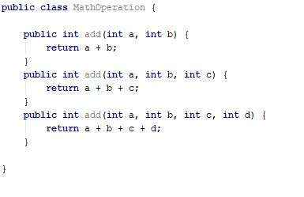

## Shapes

Create class hierarchy, starting with abstract class **Shape**:

* **Fields:**
  + **perimeter: Double**
  + **area: Double**
* **Encapsulation for these fields**
* **Abstract methods:**
  + calculatePerimeter()
  + calculateArea()

Extend Shape class with two children:

* **Rectangle**
* **Circle**

Each of them needs to have:

* **Fields:**

For **Rectangle**

* + **height: Double**
  + **width: Double**

For **Circle**

* + **radius: Double**
* **Encapsulation for these fields**
* **Public constructor**
* **Concrete methods for calculations (perimeter and area)**

## Animals

Create a class Animal, which holds two fields:

* name: String
* favouriteFood: String

The **Animal** has one abstract method explainSelf()**: String.**You should add two new classes - **Cat** and **Dog. Override** the explainSelf() method by adding concrete animal sound on a new line. (Look at examples below)

You should be able to use the class like this:

|  |
| --- |
| Main |
| **public static void** main(String[] args) {  Animal cat = **new** Cat(**"Oscar"**, **"Whiskas"**);  Animal dog = **new** Dog(**"Rocky"**, **"Meat"**);  System.***out***.println(cat.explainSelf());  System.***out***.println(dog.explainSelf()); } |

### Examples

|  |  |
| --- | --- |
| **Input** | **Output** |
|  | I am Oscar and my favourite food is Whiskas  MEEOW  I am Rocky and my favourite food is Meat  DJAAF |

### Solution

